 Pegasys
[Document Defaults]

- The Document Defaults function in Pegasys allows users to create a set of their most commonly used accounting templates and automatically load certain data elements into their forms. This feature is designed for users that consistently use the same accounting templates from day to day.
Figure 1

- From the Pegasys homepage, click Preferences located in the link strip. (Step 1)
- When the page refreshes, click the Document Defaults tab below the breadcrumbs track. (Step 2)
- When the next page appears, click Add to create a new document default. (Step 3)
Figure 1
1) Click Preferences
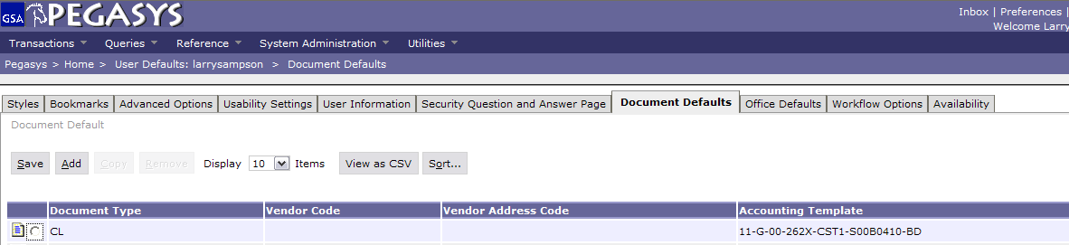
2) Click Document Defaults
3) Click Add

Figure 2
Figure 2

- Enter the doctype in the Document Type field.
(Step 1)
- Click on the Favorites Icon to select an accounting template
or
Click on the Accounting Template hyperlink to search for an accounting template
(Step 2)
- Click Save. (Step 3)

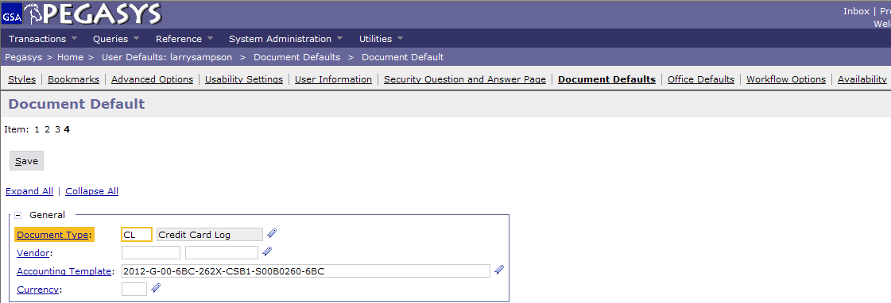
3) Click Save
2) Select the Accounting Template
1) Enter Doctype

